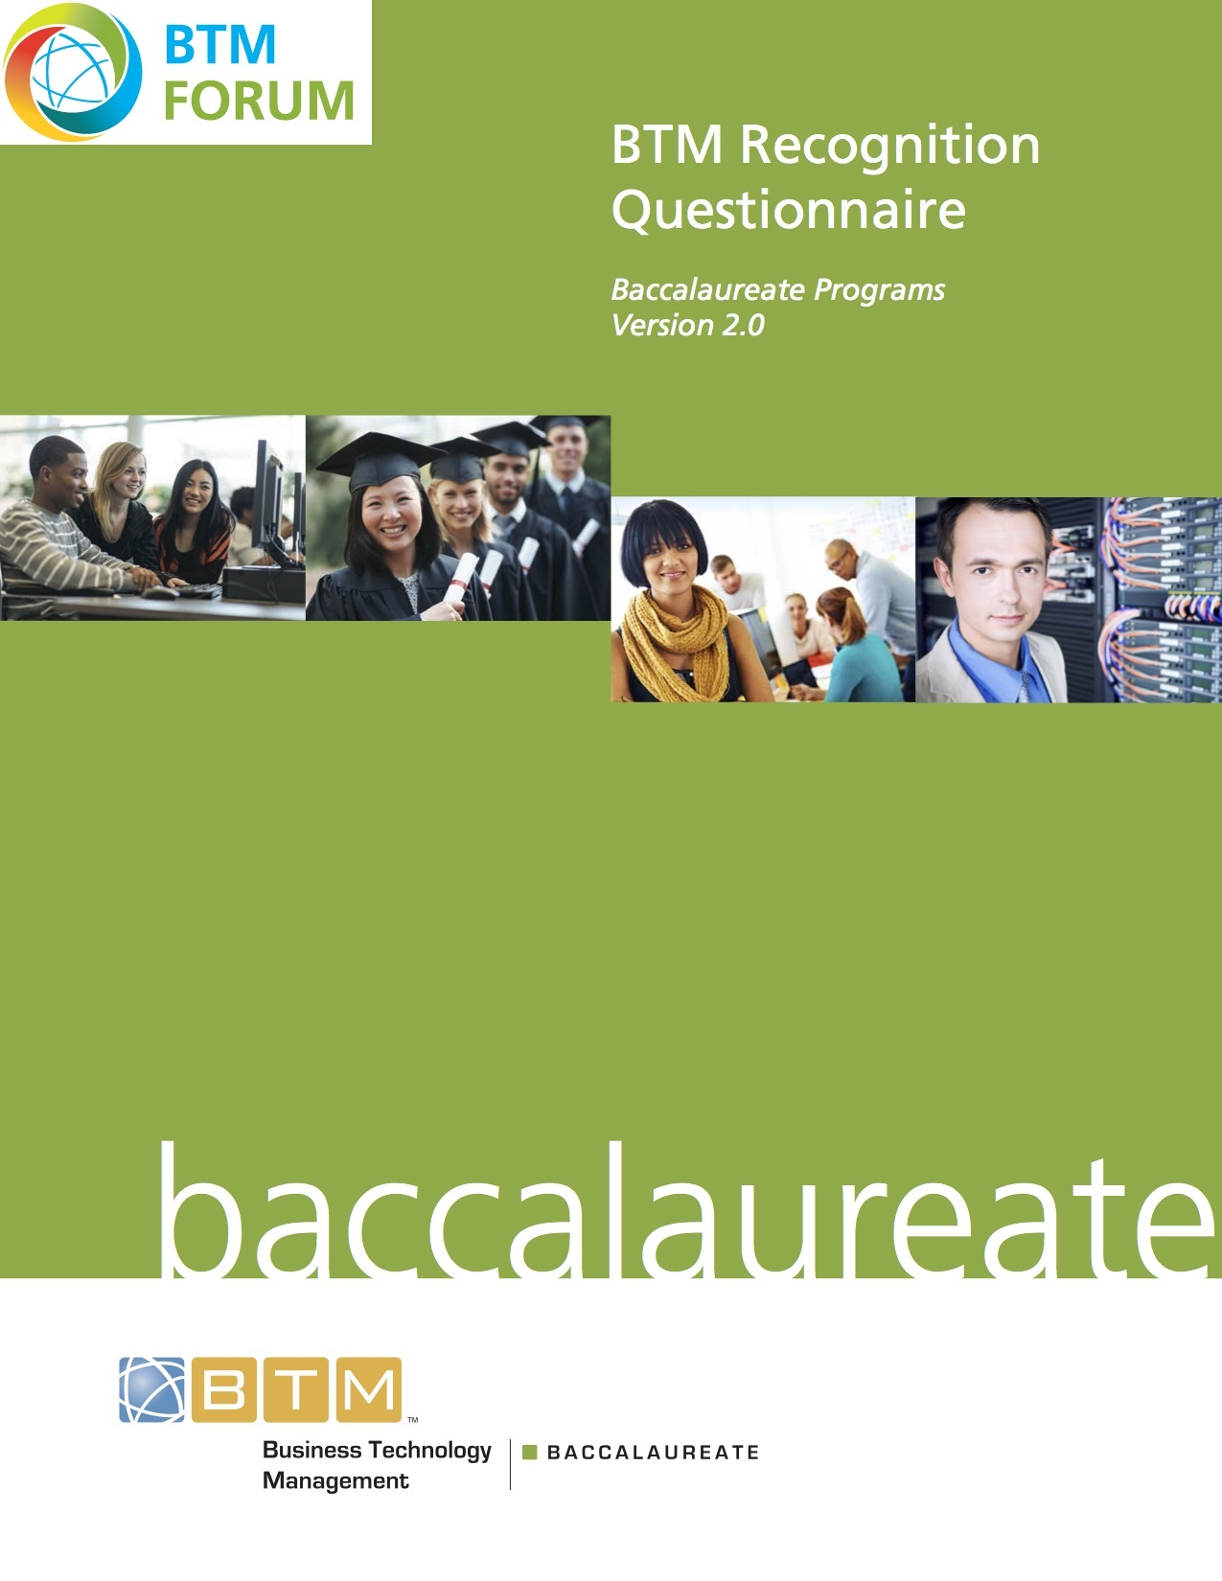
Table of Contents
Introduction 3
Requirements and Preparation 3
Submission and Distribution of questionnaire 3
Confidentiality 3
Template 4
Contact Information 6
Executive Summary 7
1.0 Curriculum 8
1.1 BTM Learning Outcomes 9
1.2 Additional quality indicators 19
1.3 Additional questions regarding curriculum 19

Introduction

The Business Technology Management Accreditation Council (BTMAC) offers an informal review to programs that have not yet produced graduates and do not qualify for an accreditation visit. The sole purpose of this Recognition evaluation is to provide comment and advice to the institution with respect to the program. This questionnaire will solely focus on the alignment of the curriculum to the BTM Learning Outcomes. To be successful, a program needs to demonstrate that it produces learning outcomes that are largely aligned with the BTM Learning Outcomes and Competency Standards.

Requirements and Preparation
The program name used on the cover of the questionnaire must be identical to that used in the institutional publications, on the BTMAC Request for Evaluation and on the transcripts of graduates. This will insure that the program is correctly identified in BTMAC records and that students can be correctly identified as being a Recognized program.

Tables in the questionnaire may be modified in format to more clearly present the information for the program. When this is done, it is suggested that a brief explanatory footnote be included about why the table was modified. Rows may be added to or deleted from tables to better accommodate program information.

Submission and Distribution of questionnaire

NOTE: No email submission permitted. No hard copy submissions will be accepted. The submission cannot be a combination of hard copy and electronic file.
The questionnaire and supplemental material should be submitted as pdf read-only files on CD, DVD, or data stick only. The exception is the educational questionnaire which must be submitted in Word format. Each questionnaire and supplement material must be self-contained in the medium submitted and must not include external hyperlinks.

To BTMAC Secretariat
Submit three copies of:
  - Questionnaire (in Word) including all appendices for each program
  - Supplemental materials to:

BTMAC Canada
CIPS National Office
1375 Southdown Road
Unit 16 – Suite 802
Mississauga, Ontario
L5J 2Z1
Telephone: (905) 602-1370
Toll Free: 1-877-ASK-CIPS (275-2477)

Confidentiality
All information supplied is for the confidential use of BTMAC and its authorized agents. It will not be disclosed without authorization of the institution concerned, except for summary data not identifiable to a specific institution or documents in the public domain.

Template
The template for the questionnaire begins on the next page.

BTMAC
Recognition
Questionnaire

for the

<Program Name>

at

<Institution Name>

<Location>

<Date>

CONFIDENTIAL

The information supplied in this questionnaire is for the confidential use of the BTMAC and its authorized agents, and will not be disclosed without authorization of the institution concerned, except for summary data not identifiable to a specific institution.

Contact Information

List name, mailing address, telephone number, fax number, and e-mail address for the primary contact person for the program.

Executive Summary
Insert one page executive summary highlighting the various areas in the questionnaire.

Suggested areas to include: when will the program be launched, what is the target for student enrollment, what level of industry involvement is there in the program, what are the entry requirements and the continuation policies.

1.0 Curriculum
Central to the outcomes-based accreditation process is demonstrating that all students have met certain learning and competency objectives by the time of graduation.

Course Outlines; provide copies of all program course outlines for every course offered to students in the program. Course outlines are not required for disciplines outside of the Business Technology Management program. Course outlines should ideally contain learning objectives that can be mapped to the BTM Learning Outcomes.

The BTM Learning Outcomes contain 70 Learning Outcomes in 7 broad competency areas, namely:

- Integrative (I1): This knowledge area contains learning outcomes that integrate the competencies developed in the following six knowledge areas. It produces a “deliverable” of direct relevance to employers.
- Personal and Interpersonal (F1): The ability to make a meaningful contribution depends upon one’s self-knowledge and ability to have constructive, long term, interactions with others. Successful leaders have strong personal and interpersonal competencies.
- Business (F2): To be effective in the workplace one must have both the broad context of business – its role and place in society – and a working knowledge of how business operates.
- Technology (F3): BTM graduates must understand information and communications technologies, their current capabilities, and future trends.
- Innovation (F4): BTM graduates are expected to be innovative in the workplace. Innovators should be able to identify new opportunities, validate and resource them.
- Technology in Business (C1): This knowledge area is designed to synthesize the knowledge and competencies gained in the foundational knowledge areas and create an additional competency in understanding: the potential (economic, personal, societal), the risks of, and the governance, acquisition, and management of ICTs in and for business.
- Processes, Project and Change (C2): BTM graduates will gain the foundations that enable them to help create well-designed business processes, well-managed projects, and support for the individuals and groups undergoing change.
In judging curricula for recognition or accreditation, the main objective is to ensure that, taken together, the material taught leads students to have met the learning outcomes by the time they graduate. Ensuring this is the case requires courses with breadth and depth, and a variety of teaching strategies.

1.1 BTM Learning Outcomes
Complete the following tables. The expected knowledge and ability standards are defined in the BTMAC Accreditation Criteria document.

Learning Outcome 1. Integrative: contains learning outcomes that integrate competencies developed in LO2 to LO6.

Course Number(s) | Course Name(s) | Learning Outcome
 |  | Demonstrate the ability to effectively plan, manage and lead a business technology project.
 |  | Demonstrate the ability to understand and analyze a business problem - collect relevant information, describe and compare options and risks, and make recommendations. Demonstrate appropriate use of relevant techniques such as systems thinking and quantitative analysis.
 |  | Demonstrate the ability to analyze a business process, develop the "to-be" design, and then to create the implementation plan and the business change management plan to implement this design.
 |  | Demonstrate the ability to design and communicate a moderately complex technology-enabled solution to a business problem.
 |  | Demonstrate understanding of how to analyze a business need, develop an RFx, evaluate the responses, and structure a contract with the successful vendor. Ability to evaluate the effectiveness, appropriateness and usability of an implemented information system.
 |  | Demonstrate the ability to examine a new technology, understand its strengths and weaknesses, evaluate its usefulness to solve business problems, and communicate the results.
 |  | Exhibit and understanding of how to use the 5 key elements of the design-thinking framework for future projects and initiatives.
 |  | Demonstrate understanding how to effectively communicate the value of current and new projects in a concise and compelling way.

LO2. Personal and Interpersonal: contains learning outcomes the build a student’s self-awareness and self management and develops the ability to have constructive, long term, interactions with others.

Course Number(s) | Course Name(s) | Demonstrable learning Outcome
 |  | Demonstrate self-awareness and self-management, including mastery of ethical reasoning, client relationship management, business courtesies and self-presentation.
 |  | Demonstrate proficiency in listening, oral and written communications skills in a business context.
 |  | Demonstrate understanding of the strengths of a diverse workplace (including ability, ethnicity, religion, gender, sexual orientation, age/generation).
 |  | Demonstrate proficiency in working with individuals, including giving and receiving feedback and resolving differences using appropriate negotiation and conflict management skills.
Demonstrate proficiency in leading work-based teams (within or between organizations), including the ability to:
 |  | Demonstrate the ability to persuade, influence, motivate and provide guidance
 |  | Demonstrate the ability to facilitate a range of group innovation, analysis and decision making techniques.
 |  | Demonstrate the ability to engender and sustain trust
 |  | Demonstrate the ability to effectively use technologies to facilitate and support group activities and processes
 |  | Be able to explain the various approaches to negotiation.
 |  | Demonstrate understanding of effective coordination of communications, time management and task organization

LO3. Business: contains learning outcomes that build a student’s knowledge of the broad context of business and provides a working knowledge of how business operates.

Course Number(s) | Course Name(s) | Demonstrable learning Outcome
 |  | Exhibit an understanding of the history, current role and future trends (e.g. globalization, social responsibility) of business within society and the global economy
 |  | Demonstrate understanding of technology-enables business design and business models (e.g. digital business models including “platforms, supply chains, open innovation, collaborative ecosystems, disruptive innovation).
 |  | Demonstrate the ability to conduct financial, operational, and reputational risk management. Articulate the implications for business decisions of cyclical and event-driven external risks (e.g. credit crunch, pandemics, global warming, peak oil).
 |  | Demonstrate an understanding of various kinds of organizations by industry sector, ownership, governance and size - their business models, key performance factors, dominant structures and processes.
 |  | Demonstrate understanding of the role, processes and structure of support functions of a business (e.g. general management, marketing, finance, R&D, IT, human resources).
 |  | Demonstrate understanding of the role, processes and structures of operational functions of a business (e.g. sales, manufacturing, distribution, customer support).
Be able to explain the current and future issues in the following topics:
 |  | IT Operations (e.g. delivery of service levels, change control, green IT
 |  | Software development (e.g. methodologies, lifecycle, emerging techniques, usability, in-house vs. off the shelf/total cost of ownership)
 |  | Infrastructure lifecycle (networks, desktop and data centre hardware, operating systems, databases)
 |  | Overall application and technology landscape lifecycle (e.g. make technology choices that will ease the integration of unpredictable future technologies).
 |  | New and emerging technologies and methods (e.g. cloud computing, mobile, social media)
 |  | Be able to explain the overall functioning of the Internet, Web, mobile, IoT etc. Be able to explain a variety of Internet technologies, including those pertinent to Web applications, mobile apps, IoT etc.
 |  | Demonstrate understanding of Digital Commerce and the application of IT, and especially digital technology, to developing innovative business models within an existing or new business strategy; understand the business opportunities from innovative digital technology for both small and large enterprises, including e-commerce development platforms in the cloud, e-commerce hubs or marketplaces, e-commerce process and payment automation, etc.
 |  | Demonstrate understanding of Digital Marketing concepts and the tools which support them: Market research and analysis; Search engine optimization (SEO); Social media marketing (SMM - blogging, LinkedIn, Twitter, etc); Online advertising tools (such as Google Adwords); The use of analytics and scorecards; Digital marketing programs; Marketing automation; Measurement and web performance optimization.

LO4. Technology: contains learning outcomes that provide an understanding of information and communications technologies.

Course Number(s) | Course Name(s) | Demonstrable learning Outcome
Demonstrate the ability to meet business requirements by planning, designing, integrating into an existing landscape, implementing, and operating contemporary technologies in each of the following:
 |  | Requirements analysis
 |  | A network and computing platform
 |  | A custom software solution (implemented locally or in the cloud)
 |  | A packaged software solution (implemented locally or in the cloud)
Exhibit and understanding of the following:
 |  | Technology architecture, and the various IT runtime infrastructure available to organizations of varying sizes to implement IT solutions
Demonstrate an understanding of IT security and compliance in the following areas:
 |  | Demonstrate understanding of, and provision of expert advice on the selection, design justification, implementation and operation of information security controls and management strategies to maintain the confidentiality, integrity, availability, accountability and relevant compliance of information systems with legislation, regulation and relevant standards.
 |  | The independent, risk-based assessment of the adequacy and integrity of controls in information processing systems, including hardware, software solutions, information management systems, security systems and tools, and communications technologies - both web-based and physical. The structured analysis of the risks to achievement of business objectives, including the risk that the organisation fails to make effective use of new technology to improve delivery and internal effectiveness. Assessment of the extent to which effective use has been made of techniques and tools to achieve sustainability and business continuity.
 |  | Exhibit an understanding of federal and provincial privacy laws such as HIPPA and PIPEDA and their impact on IT operations within an enterprise.
 |  | Exhibit an understanding of external Canadian and international IT governance and standards organizations such as ITIL, ISO, COBIT, and their impact on IT operations within an enterprise
Demonstrate the ability to develop the role, management and uses of information, including:
 |  | The role of information and data to support operations, decision making, planning and risk management
 |  | Demonstrate the ability to model, prepare and structure data to support the creation and use of information and knowledge
 |  | Ability to describe technologies for information management (e.g. reporting, analysis), knowledge management, collaboration management and content management.

LO5. Innovation: BTM graduates are expected to be innovative in the workplace. Innovators should be able to identify new opportunities, validate and resource them.

Course Number(s) | Course Name(s) | Demonstrable learning Outcome
 |  | Demonstrate understanding of how to use various approaches to generate new opportunities for projects, processes, and initiatives
 |  | Demonstrate understanding of how to use frameworks and tools to establish the value and cost associated with an opportunity (from the customer, market, and technology perspectives)
 |  | Exhibit an understanding of how to optimize the contributions of IT to competitive strategy, innovation, decision-making and operations in various sizes and types of organizations, industry sectors, processes and functions.

LO6. Technology in Business: This area synthesizes the knowledge and competencies gained in the foundational knowledge areas of business and information communications technologies and create an additional competency in understanding: the potential, risks of, governance, acquisition, and management of ICT in and for business.

Course Number(s) | Course Name(s) | Demonstrable learning Outcome
 |  | Demonstrate understanding of optimizing the contributions of IT to competitive strategy, innovation, decision-making and operations in various sizes and types of organizations, industry sectors, processes and functions.
 |  | Demonstrate understanding of utilizing IT to impact individuals, groups, and communities, including culture, social and environmental issues.
 |  | Be able to explain the innovation process, and how to introduce, adopt, and practice innovation.
 |  | Be able to explain the structure, business value, offerings, and dynamics of the Canadian and international IT industries. This includes the economics of ICTs and specific subsectors (e.g., ERP, open source, outsourcing, web, mobility).
 |  | Be able to explain the economics and governance of IT and the IT function within organizations, including IT’s role, structure, challenges and career paths.
 |  | Demonstrate understanding of the risks and mitigation strategies to business operations inherent in the implementation of information and communications technologies (e.g. systems development, data security and privacy, business continuity, outsourcing, off-shoring and infrastructure).
 |  | Demonstrate understanding of and be able to evaluate the choices and activities in procurement and management of purchased IT products and services.
Demonstrate understanding of Enterprise Architecture in the three components listed below:
 |  | 1. Demonstrate understanding of enterprise architecture as the application of architecture principles and practices to guide organizations through the business, information, process, and technology changes necessary to execute their strategies.
 |  | 2. Demonstrate understanding of enterprise analysis, design, planning, and implementation, using a holistic approach at all times, for the successful development and execution of strategy.
 |  | 3. Demonstrate the ability to utilize the various aspects of an enterprise to identify, motivate, and achieve these changes.

LO6: Process, Projects and Change: contains learning outcomes were students gain the foundations that enable them to help create well designed business processes, deliver well managed projects, and support individuals and groups undergoing change.

Course Number(s) | Course Name(s) | Demonstrable learning Outcome
 |  | Be able to explain the overall organizational learning and innovation process / life-cycle, and its role in organizational success.
 |  | Project Management - demonstrate appropriate understanding of the Project Management Institute's Project Management Body of Knowledge (PMBOK).
 |  | Demonstrate understanding and application of best practices in organizational IT change management.
 |  | Demonstrate competence in process analysis and design using applicable knowledge areas from the International Institute of Business Analysis (IIBA) Business Analysis Body of Knowledge (BABOK).
 |  | Demonstrate understanding of stakeholder requirements analysis
 |  | Describe business process improvement or re-engineering process
 |  | Demonstrate understanding of Business Process notations/symbology – BPMN, UML
 |  | Demonstrate understanding of quality assurance and testing, go-live, end of life, life cycle management, ticket management (help desk).
 |  | Demonstrate understanding of new process implementation and maintenance.
 |  | Be able to explain the importance of knowledge transfer, development, and dissemination for both explicit and tacit knowledge

1.2 Additional quality indicators
In addition to the per-course information given in Section 1.1, please summarize any other qualitative or quantitative assessment you have done which provides evidence that the learning outcomes have been met and that your curriculum is of high and/or continually improving quality. This may include surveys of students, surveys of employers, special tests given to students, interviews with students, etc.

1.3 Additional questions regarding curriculum
How does the Department manage and review its curriculum?

How does the Department ensure that the program(s) (and courses) evolves in response to industry needs (include any references or documentation to appropriate environmental scans and or Program Advisory Committee recommendations)?

Table 1.3.1 : BTM Advisory Board Members (if available)
Organization | Contact | Title

Are there other innovative aspects of the programs that deserve special mention?

Signature Attesting to Compliance

By signing below, I attest to the following:

That _______________________ (name of institution) has conducted an honest assessment of compliance and has provided a complete and accurate disclosure of timely information regarding compliance with the Business Technology Management Accreditation Council (BTMAC)

________________________________
Director (or equivalent) Name

________________________________ _______________________
Signature Date

