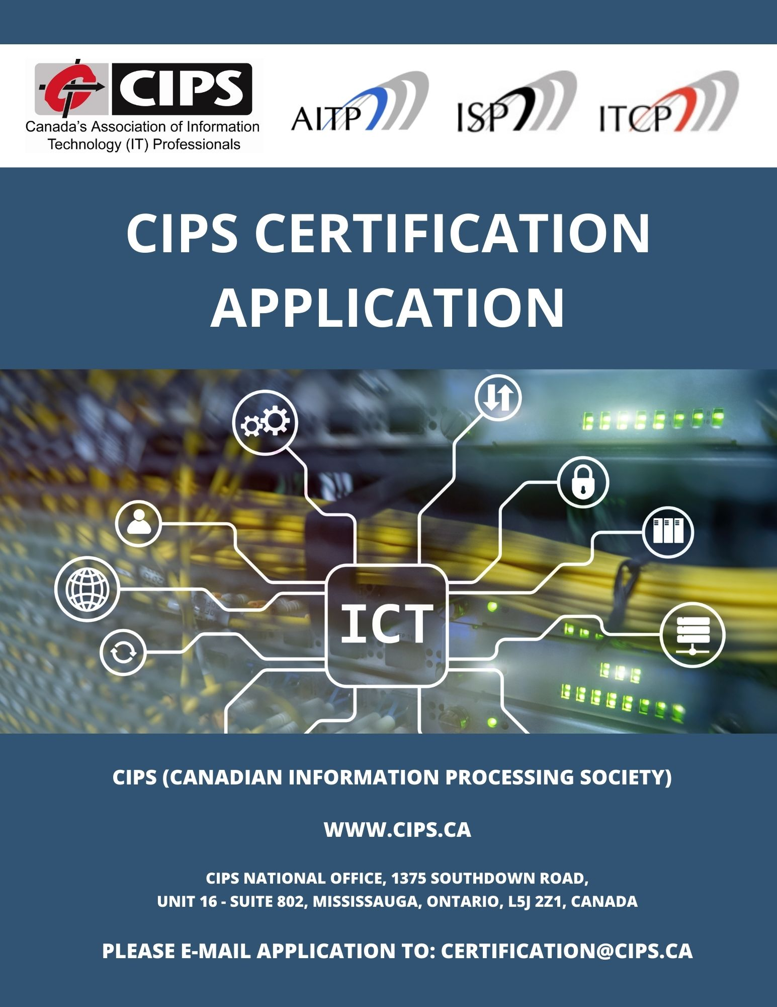
THIS APPLICATION IS FOR THE AITP, I.S.P., AND ITCP DESIGNATIONS. APPLICANTS WILL BE PROVIDED WITH THE DESIGNATION(S) THAT THEY ARE ELIGIBLE FOR BASED ON THEIR EDUCATION AND EXPERIENCE REVIEW(S).
PRIVACY CODE STATEMENT:
Personal information provided by the applicant is used solely by the CIPS National and Provincial Registrars’ office and members of the certification and their subcommittees for the purpose of:
- Assessing an applicant’s ability to meet the certification criteria
- Verifying information
- Performing an audit of Certification Council procedures
- Providing certification related products and services.

APPLICATION REQUIREMENTS:
Please submit the following documents to certification@cips.ca

1 - CIPS MEMBERSHIP – ATTACH MEMBERSHIP CARD
2 - CERTIFICATION APPLICATION REVIEW FEE PAYMENT – ATTACH PAYMENT RECEIPT
3 - PASS THE CIPS ETHICS EXAM – ATTACH ETHICS EXAM CERTIFICATE OF COMPLETION
4 - REFERENCES FOR LAST 2 YEARS (I.S.P / ITCP) or 2 SPONSORS (AITP) – ATTACH LETTERS
5 - CERTIFICATION APPLICATION – ATTACH COMPLETED APPLICATION:
  - – IT EDUCATION - OFFICIAL TRANSCRIPTS / EDUCATION EQUIVALENCY ASSESSMENTS
  - ATTACH FILLED OUT SECTION “5.1 – EDUCATION REVIEW”
  - OFFICIAL TRANSCRIPTS / EDUCATION EQUIVALENCY ASSESSMENTS MUST BE SENT DIRECTLY FROM THE INSTITUTION/ASSESSMENT CENTER TO CIPS (PREFERABLY ELECTRONICALLY)
5.2 – EXPERIENCE
- ATTACH FILLED OUT SECTION “5.2 – EXPERIENCE REVIEW”
- ATTACH RESUME/CV
- ATTACH SFIA SKILLS ASSESSMENT

3 - CIPS ETHICS EXAM:
The CIPS ethics exam tests CIPS certification applicants on their ability to apply ethical reasoning to certain situations and to encourage them to think about how they would respond to situations similar to those posed by the exam questions. The exam, which takes approximately 30 minutes to complete, currently is not proctored and is open book. The exam is for experienced and new IT practitioners and builds awareness of the key principles of professionalism and the CIPS Code of Ethics. There are no costs associated with taking the exam. Simply follow the instructions on the exam’s “getting started page” and pass the exam. The system will automatically generate a CIPS Ethics Exam Certificate of Completion, which is to be provided along with this application.

If you graduated from a CIPS ACCREDITED PROGRAM then you are exempt from the exam. Accredited IT programs recognized under the SEOUL ACCORD are also exempt.
TAKE THE CIPS ETHICS EXAM
4.1 – REFERENCES (I.S.P., ITCP):
Please provide letter(s) of reference from your employers(s) or client(s) if self-employed. The Referee(s) must be able to comment on your competence and confirm your work history over the last 24 months as documented by you in this application.
The referee(s) should be in a similar or higher professional level to you and cannot be someone who reports to you or who is a family member. Direct contact information should be provided for the referee(s).
The information should be supplied via a letter on company letterhead and include your job title, a detailed job description and precise dates of employment or client relationship. LETTERS OF APPOINTMENT OR CONTRACTS ARE NOT ACCEPTED.
Reference letters should relate work activities to SFIA Levels and their Autonomy, Influence, Complexity, and Business skills definitions.
4.2 SPONSORS (AITP) – FOR APPLICANTS WITH NO EXPERIENCE:
Sponsors must have known the applicant for two years and can either be a CIPS member or an ACTIVELY PRACTICING PROFESSIONAL.

The sponsor submission should be submitted on the professional’s letterhead and must be in one of Canada’s two official languages (English or French). Full Information on sponsor requirements can be found at WWW.CIPS.CA/RESPONSORS.

PLEASE ATTACH THE COMPLETED AND SIGNED REFERENCE/SPONSOR LETTER(S) TO THIS APPLICATION.
CIPS reserves the right to contact employers/sponsors to verify information. You should inform your referees/clients/sponsors that they may be contacted by a CIPS representative.
CIPS CERTIFICATION APPLICATION
APPLICANT INFORMATION:

FIRST NAME: __________________________

LAST NAME: __________________________
CIPS MEMBERSHIP NUMBER OR JOINED DATE: __________________________

(VIEW YOUR CIPS MEMBERSHIP NUMBER AT CIPS.CA/UPDATEMEMBERPROFILE)

MY NAME ON MY CERTIFICATE SHOULD BE: __________________________

I CERTIFY THAT THE INFORMATION SET OUT BY ME IN THIS DOCUMENT IS TRUE AND CORRECT TO THE BEST OF MY KNOWLEDGE. I BELIEVE I CAN SERVE CIPS, THE PERSONS TO WHOM I OFFER SERVICES AND THE GENERAL PUBLIC IN THE HIGHEST PROFESSIONAL MANNER. I HAVE REVIEWED AND ADHERE TO THE CIPS CODE OF ETHICS PROFESSIONAL CONDUCT (HTTPS://WWW.CIPS.CA/ETHICS). I UNDERSTAND PERSONS AND ORGANIZATIONS LISTED ON THIS APPLICATION MAY BE CONTACTED. I AUTHORIZE THE RELEASE OF INFORMATION FOR THE PURPOSE OF THIS APPLICATION.

SIGNATURE OR INITIAL: __________________________

DATE: __________________________ (MM/DD/YYYY)

5.1 – EDUCATION REVIEW
IF YOU DO NOT HAVE AN IT RELATED DIPLOMA OR DEGREE PROCEED TO SECTION “5.2 EXPERIENCE”.
NOTE: WITHOUT AN IT RELATED DIPLOMA OR DEGREE MORE IT EXPERIENCE IS REQUIRED TO BE APPROVED FOR CIPS’ CERTIFICATION(S).
SEE APPENDIX 6.1 FOR EDUCATION REQUIREMENTS

EDUCATION BEING SUBMITTED FOR REVIEW TO CIPS:
NOTE: OFFICIAL DOCUMENTS MUST BE SENT DIRECTLY FROM THE INSTITUTION/ASSESSMENT CENTER TO CIPS. COPIES RECEIVED FROM APPLICANTS ARE NOT ACCEPTED.
Name of University/College: __________________________
Last Name on Transcript: __________________________
First Name on Transcript: __________________________
Program: __________________________
City: __________________________
Attended from: __________________________ to __________________________ (YYYY/MM/DD)
Did you graduate? YES ☐ NO ☐
Date Official Transcript sent to CIPS: __________________________ (YYYY/MM/DD)
For schools outside of North America:
Canadian education equivalency service used: __________________________
Date official Canadian course-by-course education equivalency assessment sent to CIPS: __________________________ (YYYY/MM/DD)
Education equivalency assessment Reference number: __________________________

Name of University/College: __________________________
Last Name on Transcript: __________________________
First Name on Transcript: __________________________
Program: __________________________
City: __________________________
Attended from: __________________________ to __________________________ (YYYY/MM/DD)
Did you graduate? YES ☐ NO ☐
Date Official Transcript sent to CIPS: __________________________ (YYYY/MM/DD)
For schools outside of North America:
Canadian education equivalency service used: __________________________
Date official Canadian course-by-course education equivalency assessment sent to CIPS: __________________________ (YYYY/MM/DD)
Education equivalency assessment Reference number: __________________________

Exam Route (BCS / ICCP Exams):
Passed the BCS Diploma Level or Professional Graduate Level Exams? YES ☐ NO ☐
Passed the ICCP Examinations Leading to CCP (or equivalent)? YES ☐ NO ☐
Date Completed: __________________________ (YYYY/MM/DD)
Last name on Transcript: __________________________
Date Official Transcript sent to CIPS from the BCS/ICCP:
__________________________ (YYYY/MM/DD)
The BCS or ICCP must send an official transcript directly to the CIPS Office of the Registrar if applying under the Exam Route. The transcript cannot be mailed with the application.

5.2 – EXPERIENCE REVIEW

SEE APPENDIX 6.2 FOR EXPERIENCE REQUIREMENTS

- EXPERIENCE SUMMARY
Copy and paste additional Experience Templates as required for more positions. Please ensure to document your entire IT work history and to provide specific details and examples of your IT professional work responsibilities and activities.

Experience Template – Use for a single position. Copy and paste as needed.
A. Time Period - From (MM/YY) - To (MM/YY): ___________ to ___________

B. Organization: __________________________

Full Time or Part Time? (If PT indicate hours per week) ___________
C. Position Title: __________________________
D. Responsibilities:
Provide specific examples of your IT professional work responsibilities and activities and relate them to SFIA Levels and their Autonomy, Influence, Complexity, Business skills and Knowledge definitions (see: https://sfia-online.org/en/sfia-8/responsibilities).
Do not copy and paste your CV/Resume, but instead provide evidence related to SFIA levels.

AUTONOMY (see: https://sfia-online.org/en/sfia-8/responsibilities/autonomy):
- Enter specific examples related to SFIA levels here. Enter additional rows as needed for sufficient details

INFLUENCE (see: https://sfia-online.org/en/sfia-8/responsibilities/influence):
- Enter specific examples related to SFIA levels here. Enter additional rows as needed for sufficient details

COMPLEXITY (see: https://sfia-online.org/en/sfia-8/responsibilities/complexity):
- Enter specific examples related to SFIA levels here. Enter additional rows as needed for sufficient details

BUSINESS SKILLS (see: https://sfia-online.org/en/sfia-8/responsibilities/business-skills):
- Enter specific examples related to SFIA levels here. Enter additional rows as needed for sufficient details

KNOWLEDGE (see: https://sfia-online.org/en/sfia-8/responsibilities/knowledge):
- Enter specific examples related to SFIA levels here. Enter additional rows as needed for sufficient details

Experience Template – Use for a single position. Copy and paste as needed.
A. Time Period - From (MM/YY) - To (MM/YY): ___________ to ___________

B. Organization: __________________________

Full Time or Part Time? (If PT indicate hours per week) ___________
C. Position Title: __________________________
D. Responsibilities:
Provide specific examples of your IT professional work responsibilities and activities and relate them to SFIA Levels and their Autonomy, Influence, Complexity, Business skills and Knowledge definitions (see: https://sfia-online.org/en/sfia-8/responsibilities).
Do not copy and paste your CV/Resume, but instead provide evidence related to SFIA levels.

AUTONOMY (see: https://sfia-online.org/en/sfia-8/responsibilities/autonomy):
- Enter specific examples related to SFIA levels here. Enter additional rows as needed for sufficient details

INFLUENCE (see: https://sfia-online.org/en/sfia-8/responsibilities/influence):
- Enter specific examples related to SFIA levels here. Enter additional rows as needed for sufficient details

COMPLEXITY (see: https://sfia-online.org/en/sfia-8/responsibilities/complexity):
- Enter specific examples related to SFIA levels here. Enter additional rows as needed for sufficient details

BUSINESS SKILLS (see: https://sfia-online.org/en/sfia-8/responsibilities/business-skills):
- Enter specific examples related to SFIA levels here. Enter additional rows as needed for sufficient details

KNOWLEDGE (see: https://sfia-online.org/en/sfia-8/responsibilities/knowledge):
- Enter specific examples related to SFIA levels here. Enter additional rows as needed for sufficient details

Copy and paste additional Experience Templates as required for more positions. Please ensure to document your entire IT work history.
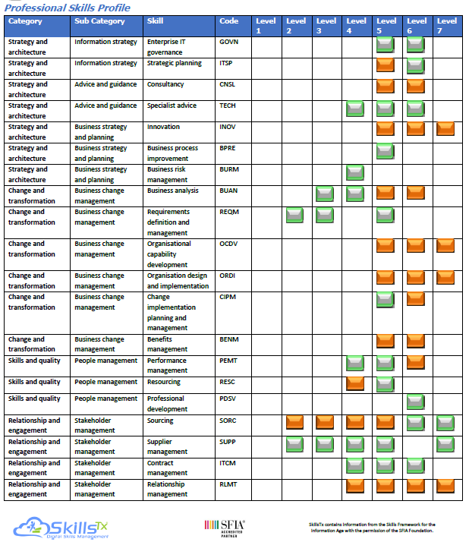
- RESUME / CV

PROVIDE AN UP-TO-DATE RESUME OR CV THAT CLEARLY DEMONSTRATES YOUR YEARS OF IT PROFESSIONAL WORK EXPERIENCE.

RESUME/CV SHOULD RELATE WORK ACTIVITIES TO SFIA LEVELS AND THEIR AUTONOMY, INFLUENCE, COMPLEXITY, BUSINESS SKILLS, AND KNOWLEDGE DEFINITIONS.

- SFIA SKILLS ASSESSMENT
(SAMPLE SFIA ASSESSMENT RESULTS)

COMPLETE THE CIPS SFIA SKILLS ASSESSMENT AND ATTACH THE RESULTS WITH YOUR APPLICATION.

This assessment will provide a detailed breakdown of your skills and what SFIA level you are at for each skill.

YOU CAN TAKE THIS ASSESSMENT AT:
https://cips.ca/skills-assessment/

APPENDIX - 6.0 - CIPS DESIGNATIONS
THANK YOU FOR APPLYING TO BE A CERTIFIED MEMBER AND HOLDER OF CIPS’ DESIGNATIONS! BASED ON YOUR ICT KNOWLEDGE AND EXPERIENCE YOU WILL BE PROVIDED WITH THE FOLLOWING DESIGNATION(S) THAT MEET YOUR SKILL LEVEL.
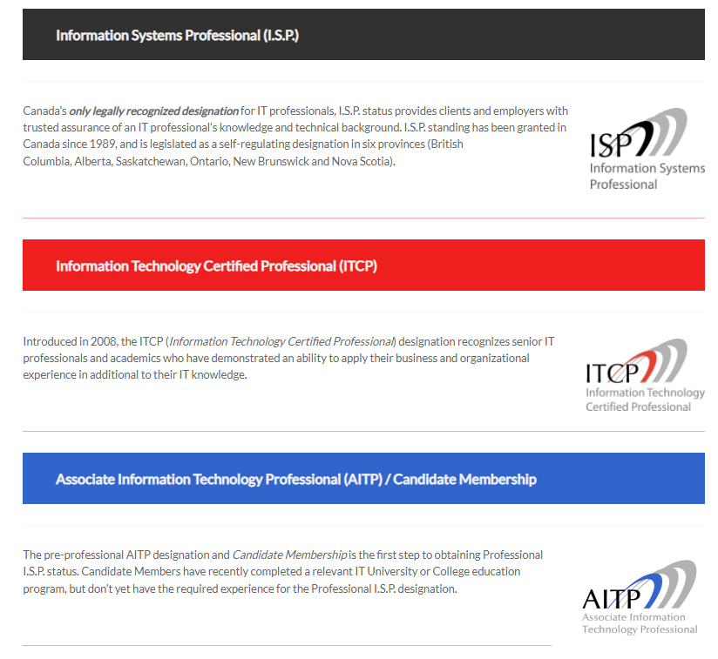

CERTIFICATION ROUTES AND REQUIREMENTS
EDUCATION PLUS EXPERIENCE ROUTES
(Includes Exam Routes):
An IT related UNIVERSITY OR COLLEGE DEGREE/DIPLOMA is required for this application route.
The following lists the required years of IT professional experience based on your IT UNIVERSITY/COLLEGE EDUCATION. To determine if your program was accredited by CIPS please visit: CIPS.CA/ACCREDITED*.

Education  AITP holders only have the required Education below, but not the IT professional experience required for the I.S.P. or ITCP.  I.S.P. & ITCP holders require the education below, along with the experience listed to the right. | Experience  I.S.P. Minimum Years of  IT Professional Work Experience  +  Currently working at a  minimum of SFIA Level 3 | Experience  ITCP Minimum Years of  IT Professional Work Experience  +  Last 2 years working at a  minimum of SFIA Level 5
Accredited * 4-year University Degree  (Computer Science, Software Engineering) | 2 | 1
Accredited 4-year University Degree (Interdisciplinary Programs) | 7 | 6
Accredited * 3-year University Degree  (Computer Science, Software Engineering) | 3 | 2
Non-accredited 4-year University Degree (Computer Science, Software Engineering, M.I.S.) | 4 | 3
Non-accredited 3-year University Degree (Computer Science, Software Engineering, M.I.S.) | 5 | 5
Accredited 3-year College/Technical Program | 4 | 3
Accredited 2-year College/Technical Program | 5 | 4
Non-accredited 3-year Public/Private College/Technical Program | 6 | 5
Non-accredited 2-year College/Technical Program | 7 | 6
Accredited one-year post-graduate I.T. program | 7 | 6
Exam Route: ICCP Examinations Leading to CCP (or equivalent) | 5 | 4
Exam Route: British Computer Society (BCS) Diploma Level Exams | 5 | 4
Exam Route: British Computer Society (BCS) Professional Graduate Level Exams | 4 | 3

* Applicants who have graduated from an accredited computing program recognized under the SEOUL ACCORD will be assessed as being equivalent to applicants from CIPS accredited undergraduate computing programs.
**Programs from privately funded educational institutions need to meet the following minimum criteria.
- Only Canadian Baccalaureate degrees will be considered.
- The Baccalaureate degree needs to have received official Provincial/Territorial Government accreditation involving an institutional accreditation, which refers to the process of officially recognizing the post-secondary institution, and a program specific review, which refers to the official recognition of a program of study.
- The Baccalaureate program needs to be a minimum of 3 academic years in length (or equivalent to six full course load terms).
- The C.I.S./C.I.T. specific course content of a program needs to be a minimum of 60% over three academic years.
- Transfer credits must be from an educational institution that has comparable or mutually acceptable standards and requirements.

EXPERIENCE ONLY ROUTES:
Demonstration of an established career in IT, generally not less than
8 YEARS OF IT PROFESSIONAL EXPERIENCE.
For applicants with a NON-IT DEGREE/DIPLOMA OR NO DEGREE/DIPLOMAS
- 8 YEARS OF IT PROFESSIONAL WORK EXPERIENCE, AND CURRENTLY WORKING AT MINIMUM OF SFIA LEVEL 3

- 8 YEARS OF IT PROFESSIONAL WORK EXPERIENCE, WITH LAST 2 YEARS AT A MINIMUM OF SFIA LEVEL 5

6.1 – EDUCATION REQUIREMENTS

EDUCATION FROM SCHOOLS IN NORTH AMERICA:
Please have your UNIVERSITY/COLLEGE(S) e-mail your official transcript directly to certification@cips.ca or mail to CIPS Office of the Registrar, 1375 Southdown Road, Unit 16, Suite 802, Mississauga, Ontario, L5J 2Z1.
-------------------------------------------------------------------------------------------------------------------------------------------------
EDUCATION FROM SCHOOLS OUTSIDE OF NORTH AMERICA:
Applicants who completed their education at an educational institution outside of North America must provide a CANADIAN COURSE-BY-COURSE EDUCATION EQUIVALENCY ASSESSMENT and a statement of equivalency from a recognized Canadian academic credential assessment service. If the equivalency assessment does not indicate that the official transcripts were received directly from the institution, official transcripts must also be sent to CIPS.
Please have the ASSESSMENT SERVICE E-MAIL YOUR OFFICIAL ASSESSMENT DIRECTLY TO CERTIFICATION@CIPS.CA, or mail to: CIPS Office of the Registrar, 1375 Southdown Road, Unit 16, Suite 802, Mississauga, Ontario, L5J 2Z1

RECOGNIZED CANADIAN ACADEMIC CREDENTIAL ASSESSMENT SERVICES FOR COURSE-BY-COURSE ANALYSIS AND A STATEMENT OF EQUIVALENCY:

WORLD EDUCATION SERVICES CANADA
WWW.WES.ORG/CA

INTERNATIONAL QUALIFICATIONS ASSESSMENT SERVICE FOR ASSISTANCE
WWW.ALBERTA.CA/INTERNATIONAL-QUALIFICATIONS-ASSESSMENT.ASPX

INTERNATIONAL CREDENTIALS ASSESSMENT SERVICE OF CANADA
WWW.ICASCANADA.CA

INTERNATIONAL CREDENTIALS EVALUATION SERVICE
(BRITISH COLUMBIA INSTITUTE OF TECHNOLOGY)
WWW.BCIT.CA/ICES/

ACADEMIC CREDENTIALS ASSESSMENT SERVICES
(MANITOBA LABOUR AND IMMIGRATION)
WWW.IMMIGRATEMANITOBA.COM

SERVICE DES EQUIVALENCE
WWW.IMMIGRATION-QUEBEC.GOUV.QC.CA/FR/FORMULAIRES/FORMULAIRE-TITRE/EVALUATION-ETUDE/MARCHE-SUIVRE.HTML
PRIVATE SCHOOLS:
Please note that the Education Review Committee does NOT review program transcripts from PRIVATE educational institutions unless the program is ACCREDITED BY CIPS. Accredited IT programs recognized under the SEOUL ACCORD are also recognized.
VERIFING INFORMATION:
The Office of the Registrar may contact an educational institution for clarification of information on any transcript provided. Submission of false information is considered a serious breach of the CIPS Code of Ethics and Standards of Conduct and may result in disciplinary action.

6.2 – EXPERIENCE REQUIREMENTS

1,000 HOURS OF PROFESSIONAL IT EXPERIENCE IN LAST 12 MONTHS (I.S.P./ITCP):
I.S.P. AND ITCP Applicants MUST demonstrate a minimum of 1000 hours of IT professional work experience during the 12 months prior to applying.
The following guidelines are used when assessing individuals who are UNEMPLOYED:
- Must have an average of 1000 hours per year of professional work experience in the three (3) years prior to becoming unemployed. Maximum unemployment period is one (1) year.
- Must show evidence of effort to maintain currency while unemployed (e.g. relevant courses and reading, relevant volunteer work etc.)
- Must show evidence of actively looking for work.

SKILLS FRAMEWORK FOR THE INFORMATION AGE (SFIA)

IT EXPERIENCE IS ASSESSED USING THE “SKILLS FRAMEWORK FOR THE INFORMATION AGE (SFIA)”
SFIA, The Skills Framework for the Information Age, is the technical competency and skills framework underlying the assessment and standards areas. SFIA was created to provide a method of mapping an individual’s professional skill level to a set of internationally relevant standard definitions.
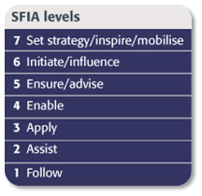
SFIA STRUCTURE:
The two parts of SFIA used for certification.
- GENERIC LEVELS OF RESPONSIBILITY
- SPECIFIC SKILL LEVEL DEFINITIONS
The generic levels define levels of responsibility and competence for IT professionals (from 1 TO 7).
The specific skills include definitions of specific ICT "SKILLS", covering all aspects of the entire spectrum of ICT professional roles and defines each of these within the same 7 levels of responsibility.
The net result – a matric of skills on one axis, competencies on the other. An IT professional can then identify the skills that relate to their specialities and work out at which competency level they are operating at.

SFIA LEVELS OF RESPONSIBILITY:
SFIA defines 7 levels of responsibility, each defined within the context of AUTONOMY, INFLUENCE, COMPLEXITY, BUSINESS SKILLS, and KNOWLEDGE. These 7 levels describe the progression of a practitioner from “follow”, being someone in an entry-level position with no discretion and working under close supervision, through to “set strategy/inspire/, mobilise”, being someone with overall responsibility for all aspects of a significant area of work.
VIEW SFIA LEVEL 3 REQUIREMENTS
VIEW SFIA LEVEL 4 REQUIREMENTS
VIEW SFIA LEVEL 5 REQUIREMENTS

VIEW ALL INDIVIDUAL SFIA SKILLS
LEARN MORE AT SFIA-ONLINE.ORG

Please E-MAIL your application, SFIA self assessment, resume, CIPS Code of Ethics exam certificate and reference letters to: certification@cips.ca

APPLICATION FEEDBACK

Thank you for completing the CIPS Certification application! Please provide your feedback below, which is greatly appreciated. Thank you!

Did you find the application easy to complete?

Were the instructions clear?

Were there any areas in the application form that were not clear?

Additional Feedback:

